Lab 7 FLCD – PARSER

Vieru Tudor-Gabriel & Toncea Ion-Alin

937/2

**GitHub Repository**

<https://github.com/TonceaAlin/FLCDlab>

**Statement**

Implement a parser using the recursive descendent algorithm.

**Example**

**g1.txt – sequence – output**

**g1.txt format:**

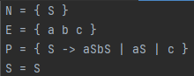

**Sequence:**

***aacbc***

**Parsing output:**

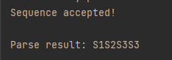

**out1.txt**

**1233**

**Implementation**

**-Grammar**

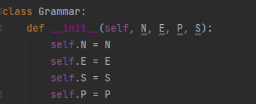

**Holding information about terminals(N), non-terminals(E), the starting symbol(S) and the set of productions(P).   
Most of the methods are implemented to operate on the g1.txt file.**

**-Parser**

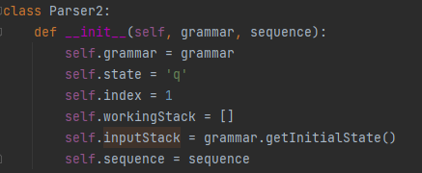**Referencing to the grammar above, having information about the state in which the recursive descendent algorithm is(q, b, f or e), the index from the sequence, the actual sequence and the stacks(working and input).  
We implemented the needed methods to parse the program with the recursive descendant algorithm: expand, back, advance, momentary insuccess and another try. Using all of them in a while and checking each piece from the sequence will get us to the final result.**